PRESS RELEASE
No. 121/SP/TKP-ASEAN2023/8/2023
PUBLIC COMMUNICATIONS TEAM

FOR IMMEDIATE RELEASE

Opening the ASEAN IIDC 2023, President: Indonesia the Locomotive of Peace in the Region
Jakarta, Kominfo Newsroom – The President of the Republic of Indonesia Joko Widodo (Jokowi) emphasized that Indonesia is in the first position in the ASEAN region as the country that has the highest confidence in the concept of religiosity.
Therefore, the chairmanship of Indonesia in ASEAN has a significant opportunity to make the region a catalyst for global peace. This is because Indonesia is regarded as a country whose citizens strongly uphold religious values such as tolerance and harmony in their daily life.
"Becoming the epicentrum of harmony that safeguards regional stability and world peace," said President Joko Widodo in his address at the ASEAN Intercultural and Interreligious Dialogue Conference (ASEAN IIDC) 2023 in Jakarta on Monday (Aug. 7, 2023).
The President said that religion shapes the morals of every individual in their daily life, which will better accommodate peace in the larger context of the region. This will also contribute to maintaining the stability of the Southeast Asian region.
“The ASEAN Community, in fact, has an increasingly heightened religious spirit,” said the president.
The Chairman of the Central Board of Nahdlatul Ulama (PBNU) KH Yahya Cholil Staquf said that the people in the ASEAN and Indo-Pacific regions have inherited the same civilization. This serves as a significant foundation for the communities in the region to build peace.
“We inherited a shared civilization value that has its roots dating back to the 3rd century. This is a significant foundation because it means that the people in the ASEAN and Indo-Pacific regions are constituents of a common cultural heritage. It is even more remarkable that their primary characteristic is the values of harmony and tolerance,” said the man who is also known as Gus Yahya.
Gus Yahya also mentioned that these shared values prompted PBNU to initiate the ASEAN IIDC 2023 as a collective movement to begin the process of consolidating civilizations in building harmony within the region and the world.
The ASEAN IIDC was initiated by PBNU in cooperation with the Ministry of Foreign Affairs and the Ministry of Religious Affairs.
“This conference serves as an initiation to start the consolidation of a significant civilization constituency that can foster the growth of harmony. Hopefully, it can inspire the entire international community,” said Gus Yahya.
The ASEAN IIDC 2023 was held concurrently with Indonesia’s role as the holder of the ASEAN Chairmanship 2023.
“The ASEAN Summit’s theme is ‘Epicentrum of Growth’. Through this intercultural and interreligious dialogue forum, PBNU supports ASEAN’s agenda of being the epicentrum of growth with the discourse of making ASEAN the Epicentrum of Peace, Tolerance, and Harmony,” said Gus Yahya.
He also hopes that the ASEAN IIDC, as a PBNU initiative, can make a meaningful contribution to the lives of ASEAN and Indo-Pacific communities.
Lesbumi’s Contemporary Panji’s Dance
The ASEAN IIDC 2023 forum also featured the Contemporary Panji’s Dance by Lesbumi PBNU. This art form represents a contemporary choreography of dance and music adapted from the Panji beksan (traditional Javanese dances).
The tale of Panji dances is rich with philosophical meanings for Southeast Asian communities. The Panji tale originated in Java in the 12th century during the era of the Jenggala and Kadiri kingdoms.
Chairman of the Indonesian Muslim Arts and Culture Institute (Lesbumi) of PBNU KH Jadul Maula explained that the Panji story also serves as a source of inspiration for literature developed in Bali, Lombok, the Malay area, Thailand, Myanmar, Cambodia, Laos, and the Philippines. The names of the characters might differ, and their backgrounds may vary. However, the themes of love and romance remain consistent.
“It means that the tale of Panji represents a successful form of diplomacy and communication to unite nations and cultures within the Indonesian Archipelago and Southeast Asia,” said Jadul.
The Panji story revolves around two characters, namely Panji Inu Kertapati (also known as Asmarabangun), the crown prince of the Jenggala kingdom, and Dewi Sekartaji (also known as Candra Kirana), the princess of the Kadiri (Daha) kingdom. Inu Kertapati and Sekartaji are two figures who are deeply in love with each other. Generally, their romantic journey culminates in their union of love.
“The romance of the love between the sun and the moon, which complements each other, is a form of harmony, balance, and eternity. Without love, care will not flourish, and empathy will not reside in the hearts of humans. Thus, the Panji story can be interpreted as a grand campaign of love for all of humanity,” said Jadul.

***
For more information, please contact:
Director General of Public Information and Communications of the Ministry of Communications and Informatics – Usman Kansong (0816785320).
Get more information at http://infopublik.id.
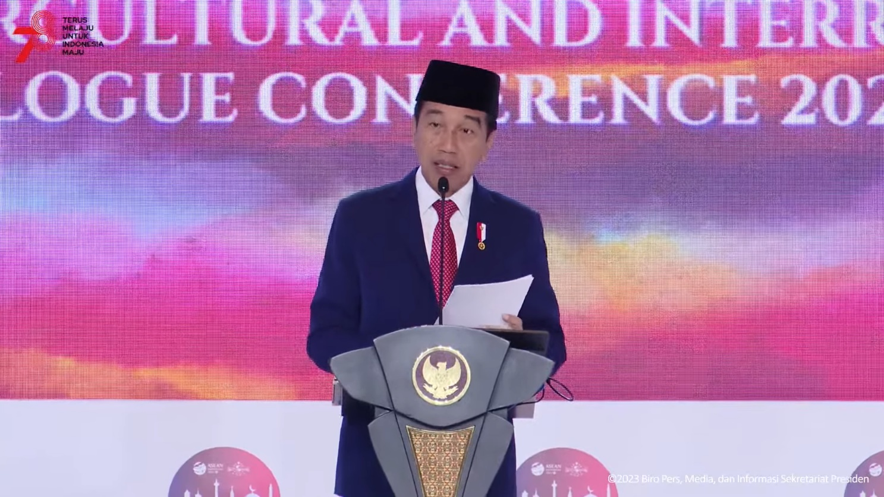
President of the Republic of Indonesia Joko Widodo (Jokowi) delivers his remarks at the ASEAN Intercultural and Interreligious Dialogue Conference (ASEAN IIDC) 2023 in Jakarta, Monday (Aug. 7, 2023). Photo: Youtube screenshot

